Christus Lutheran Church

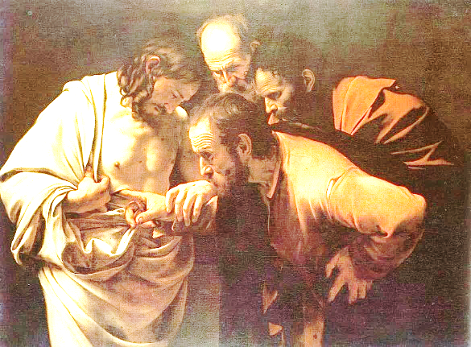
Do not disbelieve, but believe.
-John 20:27

Large Print
April 7, 2024
8am - 10:30am
PRELUDE Ann Crocker

WELCOME

INVOCATION
P: In the name of the Father, and of the Son, and of the Holy Spirit.
C: Amen

CONFESSION & ABSOLUTION
P: Let us confess our sins before God and in the presence of one another.
Kneel as you are able or remain seated; Silence for reflection
P: Almighty God, heavenly Father,
C: I confess and acknowledge that I have sinned against you, not only by outward sins, but by things I try to hide or to justify. By the cross of Christ, bring me to repentance, that I may receive your forgiveness; and by the power of the Holy Spirit, grant me to live in the righteousness of faith. Amen
P: By the suffering, death and resurrection of Jesus Christ, all your sins are forgiven you, and you are given a new heart and a new life.
C: Amen! Thanks and praise to you, heavenly Father!
Stand
PEACE
P: “May the Lord of peace himself give you peace at all times and in every way.” (2 Thessalonians 3:16)
C: May He also give you peace.

HYMN: Hallelujah! Jesus Lives! LBW #147

1 Hallelujah! Jesus lives!
He is now the Living One;
From the gloomy halls of death
Christ, the conqueror, has gone,
Bright forerunner to the skies
of His people, yet to rise.

2. Jesus lives! Why do you weep?
Why that sad and mournful sigh?
He who died our brother here
Lives our brother still on high.
Lives forever to bestow
Blessings on his Church below.

3. Jesus lives! And thus, my soul,
Life eternal waits for you;
Joined to him, your living head,
Where He is, you shall be, too;
With the Lord, at His right hand,
As a victor you shall stand.

4. Jesus lives! Let all rejoice.
Praise him, ransomed of the earth.
Praise him in a nobler song,
Cherubim of heav’nly birth.
Praise the victor king, whose sway
Sin and death and hell obey.

5. Hallelujah! Angels, sing!
Join with us in hymns of praise.
Let your chorus swell the strain
Which our feebler voices raise;
Glory to our God above
And on earth his peace and love!

PRAYER OF THE DAY
P: Let us pray. Almighty and ever-living God;
C: as we have celebrated the festival of the Resurrection of Christ, help us to show forth the power of His risen life in all we say and do,
that the earth may rejoice; through the Risen One, your Son, our Savior, Jesus Christ. Amen

Be Seated
FIRST LESSON: Acts 4:32-35
R: The first lesson is from the book of Acts, the 4th chapter
³² Now the full number of those who believed were of one heart and soul, and no one said that any of the things that belonged to him was his own, but they had everything in common. ³³ And with great power the apostles were giving their testimony to the resurrection of the Lord Jesus, and great grace was upon them all. ³⁴ There was not a needy person among them, for as many as were owners of lands or houses sold them and brought the proceeds of what was sold ³⁵ and laid it at the apostles' feet, and it was distributed to each as any had need.
R: The Word of the Lord
C: Thanks be to God

SECOND LESSON: 1 John 1:1-2:2
R: The second lesson is from 1st John, the 1st and 2nd chapters
¹ That which was from the beginning, which we have heard, which we have seen with our eyes, which we looked upon and have touched with our hands, concerning the word of life— ² the life was made manifest, and we have seen it, and testify to it and proclaim to you the eternal life, which was with the Father and was made manifest to us— ³ that which we have seen and heard we proclaim also to you, so that you too may have fellowship with us; and indeed our fellowship is with the Father and with his Son Jesus
Christ. ⁴ And we are writing these things so that our joy may be complete.
⁵ This is the message we have heard from him and proclaim to you, that God is light, and in him is no darkness at all. ⁶ If we say we have fellowship with him while we walk in darkness, we lie and do not practice the truth. ⁷ But if we walk in the light, as he is in the light, we have fellowship with one another, and the blood of Jesus his Son cleanses us from all sin. ⁸ If we say we have no sin, we deceive ourselves, and the truth is not in us. ⁹ If we confess our sins, he is faithful and just to forgive us our sins and to cleanse us from all unrighteousness. ¹⁰ If we say we have not sinned, we make him a liar, and his word is not in us.
2 ¹ My little children, I am writing these things to you so that you may not sin. But if anyone does sin, we have an advocate with the Father, Jesus Christ the righteous. ² He is the propitiation for our sins, and not for ours only but also for the sins of the whole world.
R: The Word of the Lord
C: Thanks be to God

CHILDREN’S MESSAGE
Stand
GOSPEL LESSON: John 20:19-31
P: The Holy Gospel, according to St. John the 20th chapter C: Glory to you, O Lord
¹⁹ On the evening of that day, the first day of the week, the doors being locked where the disciples were for fear of the Jews, Jesus came and stood among them and said to them, “Peace be with you.” ²⁰ When he had said this, he showed them his hands and his side. Then the disciples were glad when they saw the Lord. ²¹ Jesus said to them again, “Peace be with you. As the Father has sent me, even so I am sending you.” ²² And when he had said this, he breathed on them and said to them, “Receive the Holy Spirit. ²³ If you forgive the sins of any, they are forgiven them; if you withhold forgiveness from any, it is withheld.”
²⁴ Now Thomas, one of the twelve, called the Twin, was not with them when Jesus came. ²⁵ So the other disciples told him, “We have seen the Lord.” But he said to them, “Unless I see in his hands the mark of the nails, and place my finger into the mark of the nails, and place my hand into his side, I will never believe.”
²⁶ Eight days later, his disciples were inside again, and Thomas was with them. Although the doors were locked, Jesus came and stood among them and said, “Peace be with you.” ²⁷ Then he said to Thomas, “Put your finger here, and see my hands; and put out your hand, and place it in my side. Do not disbelieve, but believe.” ²⁸ Thomas answered him, “My Lord and my God!” ²⁹ Jesus said to him, “Have you believed because you have seen me? Blessed are those who have not seen and yet have believed.”
³⁰ Now Jesus did many other signs in the presence of the disciples, which are not written in this book; ³¹ but these are written so that you may believe that Jesus is the Christ, the Son of God, and that by believing you may have life in his name.
P: The Gospel of our Lord
C: Praise to you, O Christ

Be Seated
SERMON

Stand

HYMN: That Easter Day with Joy Was Bright
old red hymnal 94

1 That Easter day with joy was bright,
The sun shone out with fairer light,
When, to their longing eyes restored,
The Apostles saw their risen Lord.

2 O Jesus, King of gentleness,
Do thou our inmost hearts possess;
And we to thee will ever raise
The tribute of our grateful praise.

3 Jesus, who art the Lord of all,
In this our Easter festival,
From every weapon death can wield,
Thine own redeemed, thy people, shield!

4 All praise, O risen Lord, we give
to thee, who dead, again dost live;
To God the Father equal praise,
and God the Holy Ghost, we raise.

NICENE CREED
P: Together with the saints of all times and places, we confess the one, true faith, using the words of the Nicene Creed: C: We believe in one God, the Father, the Almighty, maker of heaven and earth; of all that is, seen and unseen.
We believe in one Lord, Jesus Christ, the only Son of God, eternally begotten of the Father; God from God, Light from Light, True God from True God; begotten, not made; of one Being with the Father. Through him all things were made. For us and for our salvation, he came down from heaven; by the power of the Holy Spirit, he became incarnate from the virgin Mary, and was made man. For our sake, he was crucified under Pontius Pilate; he suffered death and was buried. On the third day he rose again, in accordance with the Scriptures; he ascended into heaven, and is seated at the right hand of the Father. He will come again in glory to judge the living and the dead, and his kingdom will have no end.
We believe in the Holy Spirit; the Lord, the giver of life, who proceeds from the Father and the Son. With the Father and the Son he is worshiped and glorified. He has spoken through the prophets. We believe in one, holy, catholic and apostolic Church. We acknowledge one baptism for the forgiveness of sins. We look for the resurrection of the dead, and the life of the world to come. Amen

Be Seated
PRAYERS OF THE CHURCH

OFFERING

Stand
OFFERTORY PRAYER
P: Let us pray. Almighty God,
C: help us to see that our gift is a reflection of our faith; and grant that we will grow in faith to bring the full tithe to you, so that your kingdom may flourish on earth as in heaven. Amen

THE LORD’S SUPPER
GREAT THANKSGIVING LBW p.88
PROPER PREFACE LBW p.88
SANCTUS LBW p.89
WORDS OF INSTITUTION LBW p.89
LORD’S PRAYER
Be Seated
AGNUS DEI LBW p.92
DISTRIBUTION
Stand
POST-COMMUNION BLESSING

ANNOUNCEMENTS

BENEDICTION
P: The Lord bless you and keep you; the Lord make his face to shine on you and be gracious to you; the Lord lift
his countenance upon you and give you peace; in the
name of the Father, and the Son and the Holy Spirit.
C: Amen

HYMN: All Hail the Power of Jesus’ Name LBW #328
Vs. 1,4,5,6
1 All hail the power of Jesus’ name!
Let angels prostrate fall;
Bring forth the royal diadem
And crown him Lord of all.
Bring forth the royal diadem
And crown him Lord of all.

4 Hail him, you heirs of David’s line,
Whom David Lord did call
The God Incarnate, man divine
And crown him Lord of all.
The God Incarnate, man divine
And crown him Lord of all.

5 Sinners, whose love can ne’er forget
The wormwood and the gall,
Go, spread your trophies at his feet
And crown him Lord of all.

Go, spread your trophies at his feet
And crown him Lord of all.

6 Let ev’ry kindred, ev’ry tribe
On this terrestrial ball
To him all majesty ascribe
And crown him Lord of all.
To him all majesty ascribe
And crown him Lord of all.

DISMISSAL
P: We go in peace, to fear God, love God, and trust God.
C: He is to be feared and loved, and He can be trusted. Amen

POSTLUDE Ann Crocker

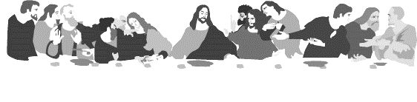
HOLY COMMUNION
All the baptized who believe in the true presence of Christ
in these elements, the bread and wine,
and who know their need of forgiveness,
are welcome to receive the Lord’s Supper.
(1 Cor. 11:23-25; Matt.26:26-28; Mark 14:22-24; Luke 22:19, 20)

Both wine (red) and grape juice (white) are available.
Gluten-free wafers are available – please ask your server for the gluten free wafer if you so choose.
Children who have not received instruction, and those who do not believe in the true presence of Christ in the Supper, may come forward with arms crossed over their hearts to receive a blessing.
Our mission is to invite people of all nations
into fellowship with Jesus Christ,
and to make them His disciples
through preaching and teaching Christ crucified, risen
and coming again as the only hope of eternal salvation.

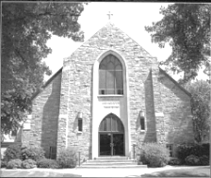
Christus Lutheran Church
120 N. Main St. Clintonville, WI 54929
(715) 823-6521 ● christus@charter.net ●
www.christusclintonville.org
Pastors: Brian Crocker & Shelly Klemp

